



**Technical**

**MANUAL**

*A.I.D.P. SYSTEMS*



**From**

POLYTECHNIC UNIVERSITY OF THE PHILIPPINES

COLLEGE OF ENGINEERING

COMPUTER ENGINEERING DEPARTMENT

October 2017

**Revision Sheet**

|  |  |  |
| --- | --- | --- |
| **Release No.** | **Date** | **Revision Description** |
| Rev. 0 | 10/20/2017 | For the Dr. Arvin Dela Cruz Compliance |
|  |  |  |
|  |  |  |
|  |  |  |
|  |  |  |
|  |  |  |
|  |  |  |



|  |  |
| --- | --- |
| C:\Documents and Settings\CRESCEL\My Documents\Downloads\pup logo.jpg | **User’s Manual**  **Authorization Memorandum** |

I have carefully assessed the User’s Manual for BFAR-NIFTC System. This document has been completed in accordance with the requirements of System Development Methodology.

MANAGEMENT CERTIFICATION - Please check the appropriate statement.

______ The document is accepted.

______ The document is accepted pending the changes noted.

______ The document is not accepted.

We fully accept the changes as needed improvements and authorize initiation of work to proceed. Based on our authority and judgment, the continued operation of this system is authorized.

_______________________________ _____________________

SUINAN, ANGELO NICHOL A. (09953274805) DATE

System Analyst

_______________________________ _____________________

JAMLANG, TEEJAY Y. DATE

Project Manager

_______________________________ _____________________

Pol, Roman Tristan A. DATE

Programmer

_______________________________ _____________________

Punzalan, Daniel James M. DATE

Programmer

**USER'S MANUAL**

**TABLE OF CONTENTS**

Page #

A. GENERAL INFORMATION A-1

1.1 System Overview A-1

1.2 Project References A-2

1.3 Authorized Use Permission A-2

1.4 Points of Contact A-2

1.4.1 Information A-2

1.4.2 Coordination A-2

1.4.3 Help Desk A-2

1.5 Organization of the Manual A-2

1.6 Acronyms and Abbreviations A-3

B. SYSTEM SUMMARY B-1

2.1 System Configuration B-1

2.2 Data Flows B-1

2.3 User Access Levels B-1

C. USER GUIDE C-1

3.1 Logging On C-1

3.2 System Menu C-1

3.3 ATTENDANCE SYSTEM C-1

3.4 INVENTORY SYSTEM C-1

3.3 FISH DISPERSAL SYSTEM C-1

3.3 FISH PRODUCTION SYSTEM C-1

3.5 Other Features C-1

3.5 Exit System C-1

D. USING the SYSTEM (ONline) D-1

4.x [System Function Name] D-1

4.x.y [System Sub-Function Name] D-1

4.2 Special Instructions for Error Correction D-1

4.3 Caveats and Exceptions D-1

A. Appendix D-1

B. Appendix D-2

**1.0 GENERAL INFORMATION**

***NOTE TO AUTHOR:*** *highlighted, italicized text throughout this template is provided solely as background information to assist you in creating this document. Please delete all such text, as well as the instructions in each section, prior to submitting this document.* ***ONLY YOUR PROJECT-SPECIFIC INFORMATION SHOULD APPEAR IN THE FINAL VERSION OF THIS DOCUMENT.***

*The User’s Manual provides the information necessary for the user to effectively use the automated information system.*

# GENERAL INFORMATION

## 1.1 System Overview

An intelligent aid for impaired individuals:

1. A software system based on the Windows 7 SmartPhone Platform.
2. Graphical Scheduler system for notification
3. User Medical Referencing System
4. GPS / Electronic Compass Location
5. System name or title: HOPE
6. System code: WP7
7. System category:
8. *Major application:* performs clearly defined functions for which there is a readily identifiable security consideration and need
9. *General support system:* provides general ADP or network support for a variety of users and applications
10. Operational status:
11. Partially Operational
12. Under development

## 1.2 Project References

References that were used in preparation of this document in order of importance to the end user.

<http://msdn05.e-academy.com/utd_cs>

<http://create.msdn.com/en-us/home/getting_started>

<http://windowsteamblog.com/windows_phone>

<http://www.microsoft.com/windowsphone/en-us/howto/wp7/default.aspx>

<http://social.msdn.microsoft.com/Forums/en-US/windowsphone7series>

<http://channel9.msdn.com/Learn/Courses/WP7TrainingKit/WP7GettingStarted>

<http://en.wikipedia.org/wiki/WP7>

## 1.3 Authorized Use Permission

iNiTech provides you with access to a variety of resources on this website (“Web Site”), including documentation and other product information (collectively the “Documentation”), download areas, communication forums, and other services (collectively "Services"), software, including developer tools and sample code (collectively “Software”), and Application Program Interface information (“APIs”).  The Documentation, Services, Software, and APIs (including any updates, enhancements, new features, and/or the addition of any new Web properties to the Web Site), are subject to the following Terms of Use ("TOU"), unless we have provided those items to you under more specific terms, in which case, those more specific terms will apply to the relevant item. Microsoft reserves the right to update the TOU at any time without notice to you. The most current version of the TOU can be reviewed by clicking on the "Terms of Use" hypertext link located at the bottom of our Web pages.

## 1.4 Points of Contact

### 1.4.1 Information

The points of organizational contact (POCs) that may be needed by the document user for informational and troubleshooting purposes are currently not available.

### 1.4.2 Coordination

The list of organizations that require coordination between the project and its specific support function (e.g., installation coordination, security, etc.) are currently not available.

### 1.4.3 Help Desk

Help desk information including responsible personnel phone numbers for emergency assistance is currently not available.

## 1.5 Organization of the Manual

User’s Manual v0.01.

## 1.6 Acronyms and Abbreviations

Provide a list of the acronyms and abbreviations used in this document and the meaning of each.

App: Application

MS: Microsoft

MSDN: Microsoft Developer Network

Wiki: Wikipedia

WP7: Windows 7 SmartPhone Platform

**2.0 SYSTEM SUMMARY**

# SYSTEM SUMMARY

*This section provides a general overview of the system written in non-technical terminology. The summary should outline the uses of the system in supporting the activities of the user and staff.*

## 2.1 System Configuration

Windows Phone features a new user interface, based upon Microsoft's Windows Phone 7 design system, codenamed Metro. The home screen, called the "Start screen", is made up of "Tiles". Tiles are links to applications, features, functions and individual items (such as contacts, web pages, applications or media items). Users can add, rearrange, or remove Tiles. Tiles are dynamic and update in real time - for example, the tile for an email account would display the number of unread messages or a Tile could display a live update of the weather.

## 2.2 Data Flows

Users input text by using an on-screen virtual keyboard, which has a dedicated key for inserting emoticons. Spell checking and word prediction are supported, and users may change a word after it has been typed by tapping the word; similar words that may have been the word the user was trying to type will then be suggested as alternatives.

## 2.3 User Access Levels

The Primary user and family member and authorized user may be able to add and modify data and information.

**3.0 GETTING STARTED**

# GETTING STARTED

This section provides a general walkthrough of the system from initiation through exit. The logical arrangement of the information shall enable the functional personnel to understand the sequence and flow of the system. Screenshots are provided for additional informantion

## 3.1 Logging On

A user ID and password is required to log onto web interface. It is given by the System administrator. Navigate through the admin’s given url slash login (url/login).

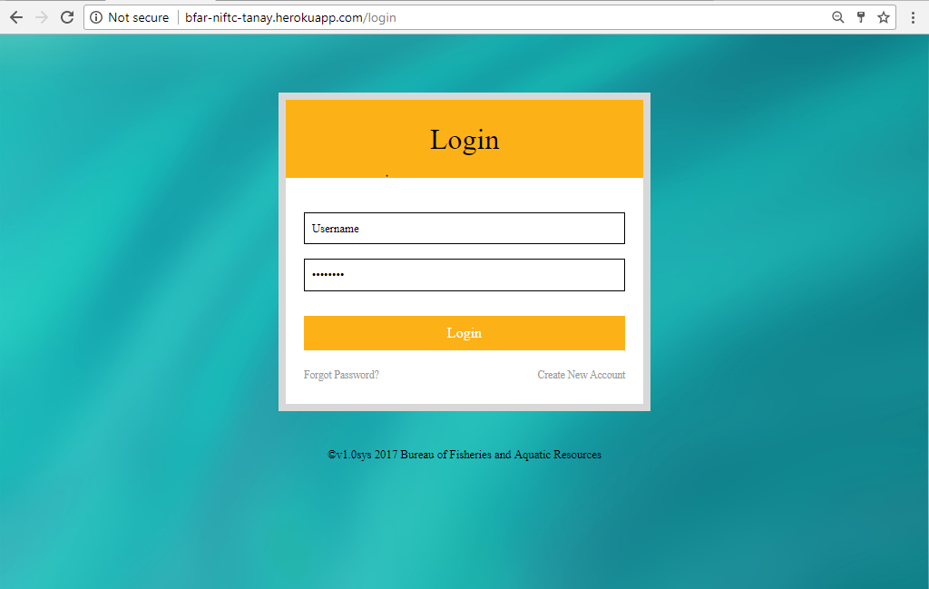

## 3.2 System Menu

After logging in you will be redirected at the homepage illustrated in the image below is the homepage. It is composed of the Four Systems. Attendance(3.3), Inventory(3.4), Fish Dispersal(3.5) Fish Production(3.6).

Other feature included in the homepage is the 7-day weather forecast for Tanay, Rizal. It would only work if your computer has an internet.

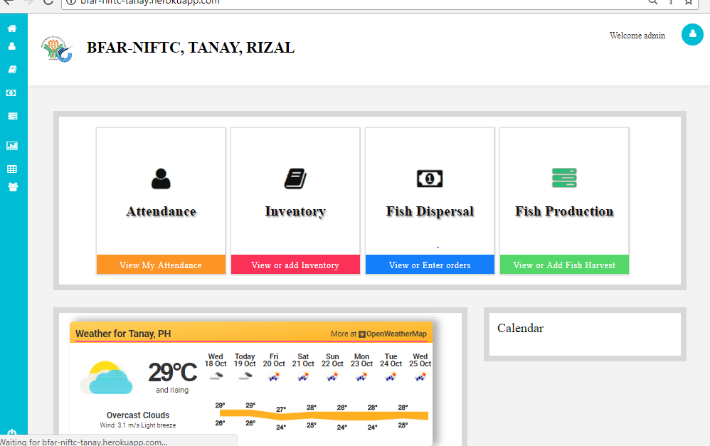

### 3.1 ATTENDANCE SYSTEM

By Clicking the Attendance tab in the homepage, the page will be redirected to the Attendance System landing page. The image below illustrates the landing page. Attendance can be sorted by entering the start date and end date.

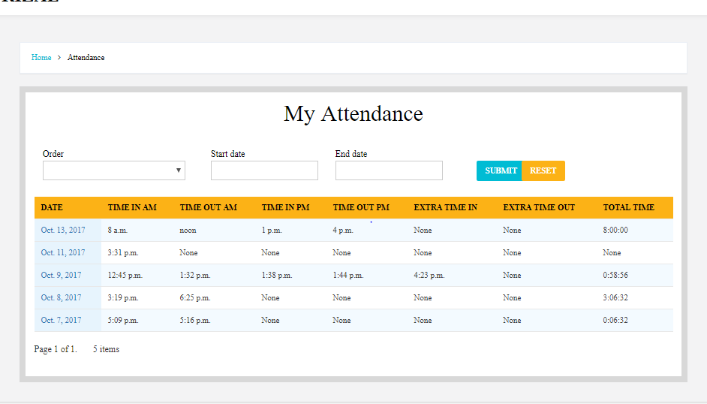

By clicking the leftmost column, the page will be redirected to the individual attendance. It displays the information of the specific date like time in’s and time outs. This page is primarily use for adding notes if a specific time is wrong.

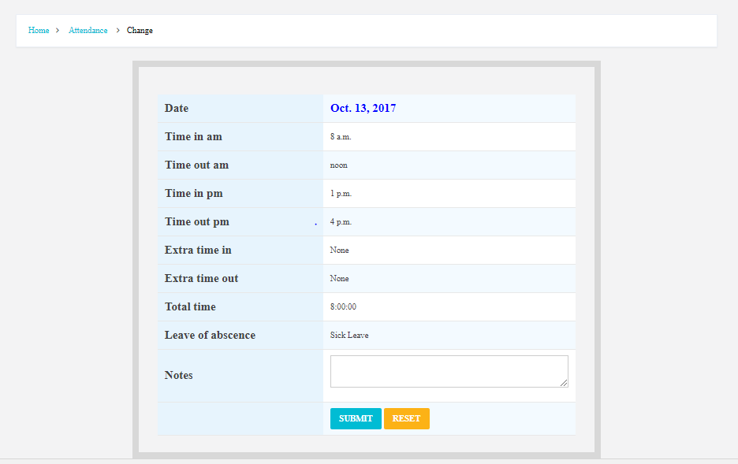

**Frequently Asked Questions**

1. No fingerprint? How to register your Biometrics to the system.

1. Contact System Administrator for registering your Finger Print Biometrics

2. The System Administrator will assist you on the creation of your biometrics.

3. After successfully confirming your biometrics you may proceed to registering your attendance through the fingerprint scanner.

1. My time in or time out is wrong for a specific date?
   1. You may add notes by clicking the specific date on the leftmost column and then add notes. Then notify the personnel for the correction. It is recommended to see login to the system to view your attendance regularly to check for corrections.

### 3.3 INVENTORY SYSTEM

By Clicking the Inventory tab in the homepage, the page will be redirected to the Inventory System landing page. The image below illustrates the landing page. Items can be sorted by entering the start date and end date.

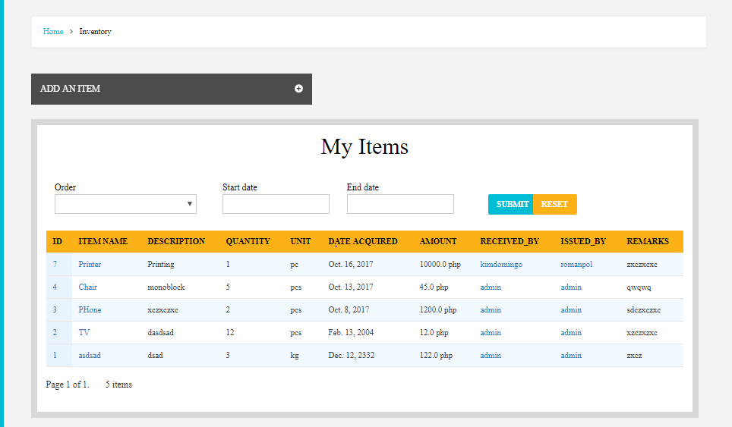

By clicking the add item from the image above, the page will be redirected to add item page. The user will input must input the item name, description, quantity, unit, Category, date acquired, amount, issued by, received by. Remark is optional then the page will be redirected to the item that been added

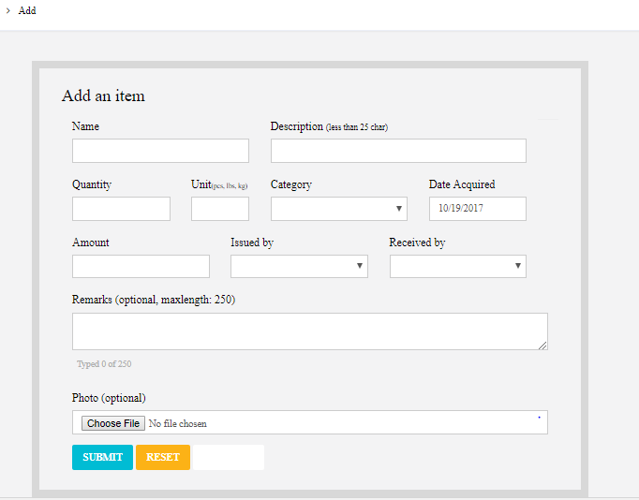

After successful add of items the page will be redirected to the added item. The user can only change the remarks. Below illustrate an item change/view

**Frequently Asked Questions**

1. I can’t change the items that I’ve added?
   1. Contact an assigned personnel that has access on the inventory admin site. If you have an access navigate to <http://url/admin/inventory>
2. I want to print my inventory?
   1. Contact an assigned personnel that has access on the inventory admin site. If you have an access navigate to <http://url/admin/inventory>. Click Export.

### 3.4 FISH DISPERSAL SYSTEM

## 3.3 Changing User ID and Password

Sign in to the Web Interface.

Click Settings at the top of the main page, and open the Accounts and Import tab.

Click on Account settings.

In the new window, click Change password under the Personal information option.

Enter your current password and your new password.

## 3.4 Exit System

Click on Exit.

**4.0 ADMIN GUIDE**

# ADMIN

*This section provides a detailed description of system functions. Each function should be under a separate section header, 4.1 - 4.x, and should correspond sequentially to the system functions (menu items) listed in subsections 3.2.1 - 3.2.x.*

## 4.x Creating a user

Provide a system function name and identifier here for reference in the remainder of the subsection. Describe the function in detail and depict graphically. Include screen captures and descriptive narrative.

## 4.2 Assigning a user a level Access

As a condition of your use of the Services, you will not use the Services for any purpose that is unlawful or prohibited by these terms, conditions, and notices. You may not use the Services in any manner that could damage, disable, overburden, or impair any Microsoft server, or the network(s) connected to any Microsoft server, or interfere with any other party use and enjoyment of any Services. You may not attempt to gain unauthorized access to any Services, other accounts, computer systems or networks connected to any Microsoft server or to any of the Services, through hacking, password mining or any other means. You may not obtain or attempt to obtain any materials or information through any means not intentionally made available through the Services.

## 4.3 Biometrics Registration

Insert Insert Insert Insert Insert Insert Insert Insert Insert Insert Insert Insert Insert Insert Insert Insert Insert Insert Insert Insert Insert Insert Insert Insert Insert Insert Insert Insert Insert Insert Insert Insert

## 4.3 Adding fish

The services that iNiTech provides to you are subject to the following Terms of Use ("TOU"). iNiTech reserves the right to update the TOU at any time without notice to you. The most current version of the TOU can be reviewed by clicking on the "Terms of Use" hypertext link located at the bottom of Microsoft Connect Web pages

**10.0 APPENDIX**

# Appendix

*This section describes and depicts all addition information about the system. Use screen prints as needed to depict examples of text under each heading.*

*Menu Flow:*

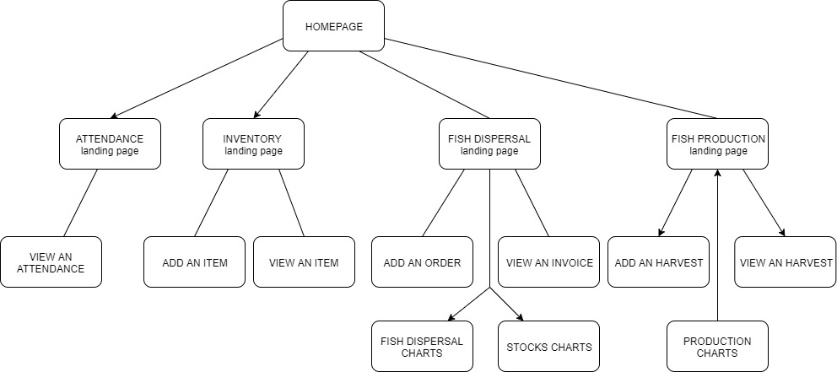

# Appendix

*Screen Shots:*